SAMPLE: a fictional building, prepared by Tier 2 Desk to show the format of its work. Not a real compliance document; names, numbers and equipment are made up.

SAMPLE Cedar Row Holdings LLC (fictional)

SAMPLE - Cedar Row Office (fictional)
Commerce building ID: SAMPLE-000000
1200 W Example Ave, Spokane, WA 99201 (fictional)

Energy Management Plan

Plan adoption date: 2026-10-01
Last Updated: 2026-10-01

Table of Contents

Building Summary
5.1 An Energy Management Plan has been established and maintained in accordance with the standard.
Building Information
 | Building Information
Site Name: | SAMPLE - Cedar Row Office (fictional)
Address: | 1200 W Example Ave, Spokane, WA 99201 (fictional)
Construction Year: | 1998
Facility Description: | Two-storey office building with ground-floor tenant suites, built in 1998. Four packaged rooftop units with gas heat serve the floors; one gas water heater serves the restrooms; a building automation system schedules the rooftop units. Fictional building used to show the format of Tier 2 Desk's work.
Weekly Operating Hours: | 55 hours a week: Monday to Friday 7:00-18:00; closed weekends

Building Activity Type
Building Activity | Gross Floor Area (Square Feet)
Office | 30,400 Sq. Ft.
Retail Store | 3,800 Sq. Ft.
Total GFA | 34,200 Sq. Ft.

Energy Analysis
5.1.2.6: If applicable, recommended energy efficiency measures (EEMs) were identified in the energy audit report(s) for this building.
5.1.2.7: If applicable, EEMs were implemented to ensure compliance with the standard. Include a list of EEMs that have been implemented and dates of implementation, including the following: An operations and maintenance (O&M) program as defined in Section 6 for the EEMs, An implementation plan for EEMs, including EEM commissioning Staff training plan for EEMs Ongoing commissioning plans for the EEMs
Energy Analysis (If applicable)
EEM Name | Useful Life of EEM (yrs) | Total Project Cost | Total Savings | Measure Implementation Date
None. Tier 2 requires no energy audit; no EEMs were implemented for compliance.

Energy Manager
5.1.1 The building owner has designated an energy manager (EM) to develop and maintain an energy management plan for the building.
Energy Manager’s name: Riley Example
Energy Manager’s association with the building: Property manager (SAMPLE)

Energy Accounting
5.1.2.2 WNEUI and EUI from the initial year of compliance for building.
5.1.2.3 Documented annual updates of net energy use, WNEUI and EUI.
5.1.2.4 Documented annual comparison of the net WNEUI and EUI to the energy target.
Our building’s net energy is monitored and recorded in accordance with sections 5.1.2.2, 5.1.2.3 & 5.1.2.4.
Year | Net Energy Use (kBTU/yr) | WNEUI | EUI | EUIt | Difference between WNEUI and EUIt | Difference between EUI and EUIt
2025 | 1,983,600 | 57.2 | 58.0 | TODO (QEM, Form B)

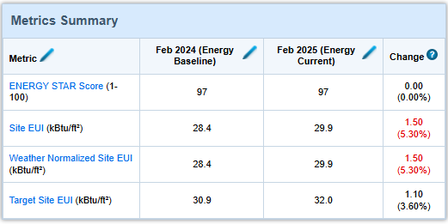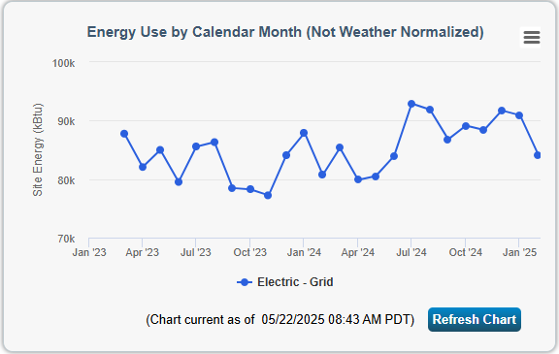

Building Changes
5.1.2.5: Documentation of original, current, and changes in number of occupants, weekly operating hours, or time of day scheduled for occupancy, production rates, and energy using equipment that would have caused change in the measured WNEUI and EUI.
Baseline occupancy: About 85% leased; about 120 people on a typical weekday. Weekly operating hours: 55 hours a week: Monday to Friday 7:00-18:00; closed weekends.
Date of Change | Description of Building Change | Impact of Change
2025-01-01 | Baseline: 85% leased, Mon-Fri 7:00-18:00 | Baseline for the EUI tracking

Occupant and Stakeholder Communication
5.1.2.8: Method developed to inform occupants about the benefits of efficient energy use and to instruct them in the use and adjustment of operable windows, HVAC system controls, and lighting system components and controls. This shall include materials (electronic or printed) as appropriate.
5.1.3: The Energy Manager has provided access to the energy management plan for building occupants and other stakeholders on an annual basis.

Intended Recipient(s) | Communication | Method | Frequency
All tenants | Energy Management Plan available on request; summary of the year's energy use | Email from the property manager | Annually
All occupants | How to use thermostats, blinds and lighting controls; who to call about comfort | Tenant guide and lobby notice | Annually and at move-in
Maintenance contractor | Changes to schedules and setpoints | Work order notes | As changes occur

Training Plan
5.1.2.9: Training plan developed for the O&M personnel to operate the building systems to achieve established indoor environmental targets with optimum energy efficiency.
Audience | Training | Cadence | Details
Property manager and maintenance technician | Clean Buildings O&M program review | Annually | Walk through the O&M task list, schedules, and the BAS setpoints
HVAC service contractor | RTU economizer and controls checks | At each quarterly service | Per the ASHRAE 180 tasks in the O&M tool

Capital Management Plan
5.1.2.10: Capital management plan identifies equipment for replacement with energy efficient and ENERGY STAR rated equipment in case of failure.
 |  |  | Budget
Current Equipment | Remaining Useful Life (years) | Energy Efficient Replacement Option | 2027 | 2028 | 2029 | 2030 | 2031
RTU-1 and RTU-2 (1998) | 0-2 | High-efficiency packaged heat pump units | $48,000 | $48,000
WH-1 gas water heater (2012) | 1 | Heat pump water heater | $6,500
BAS controller (2010) | 3 | Controller and software upgrade |  |  | $12,000

Contact List
5.1.2.11: A contact list of suppliers and manufacturers’ local representatives of energy efficient equipment, qualified energy auditor, the Energy Manager, and the building owner.
The contact list for our energy management staff, preferred energy auditors and other contractors, and local suppliers can be found in the table below.

Energy Management Staff
Role | Organization | Contact Name | Contact Info
Building Owner | SAMPLE Cedar Row Holdings LLC | Jordan Sample | 509-555-0100
Energy Manager | SAMPLE Example Property Management | Riley Example | 509-555-0101

Contractors
Scope of Work | Company | Contact Name | Contact Info
HVAC service | SAMPLE Example Mechanical (fictional) | Service desk | 509-555-0102
Energy Audit | Not required for Tier 2

Manufacturer/Suppliers
Equipment | Company | Contact Name | Contact Info
HVAC | SAMPLE Example HVAC Supply (fictional) | Counter sales | 509-555-0103
Electrical | SAMPLE Example Electric Supply (fictional) | Counter sales | 509-555-0104

Lighting
5.1.2.12 The current lighting schedule and the calculated lighting power density along with the potential savings from any potential EEMs.
5.1.2.13 The current lighting satisfaction survey and lighting checklist as described in Appendix D of Performance Measurement Protocols for Commercial Buildings 1 or as approved by the AHJ.
Not required: this is a Tier 2 covered building (lighting section exception 3 in the template).

Signature
5.1.4: The building owner has reviewed and signed the energy management plan annually.
This plan was prepared by Tier 2 Desk (SAMPLE) for SAMPLE Cedar Row Holdings LLC (fictional) in order to demonstrate compliance with Tier 2 covered building requirements of the Clean Buildings Performance Standard (WAC 194-50).
Building Owner/Authorized Representative:
Printed Name: __________________________
Signature: _______________________________
Date: _________________
Qualified Energy Manager reviewing this plan: TO BE NAMED (SAMPLE), certification number TODO-QEM.

Appendix 1.

